**Lesson3 APP3:**

**Launch an Instance in a Placement Group**

**Creating a Placement Group:**

* Click on *Create Placement Group*

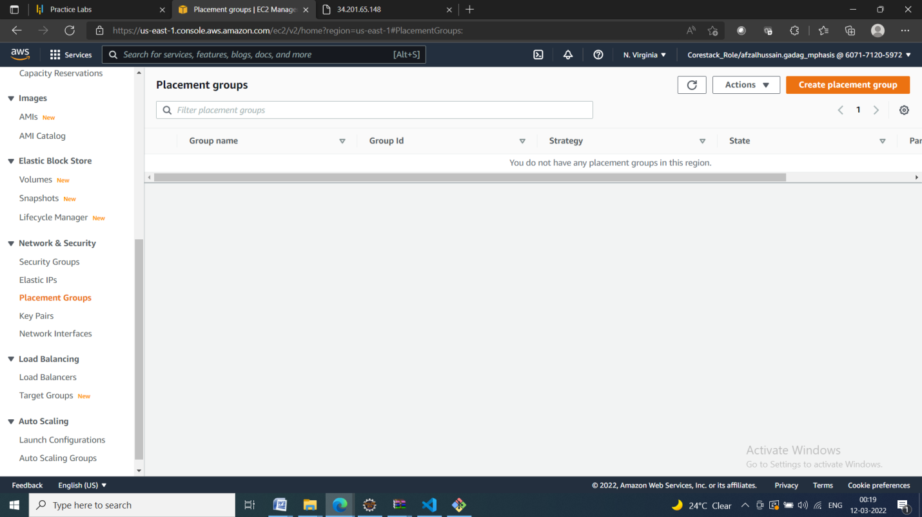

* Provide a name and strategy

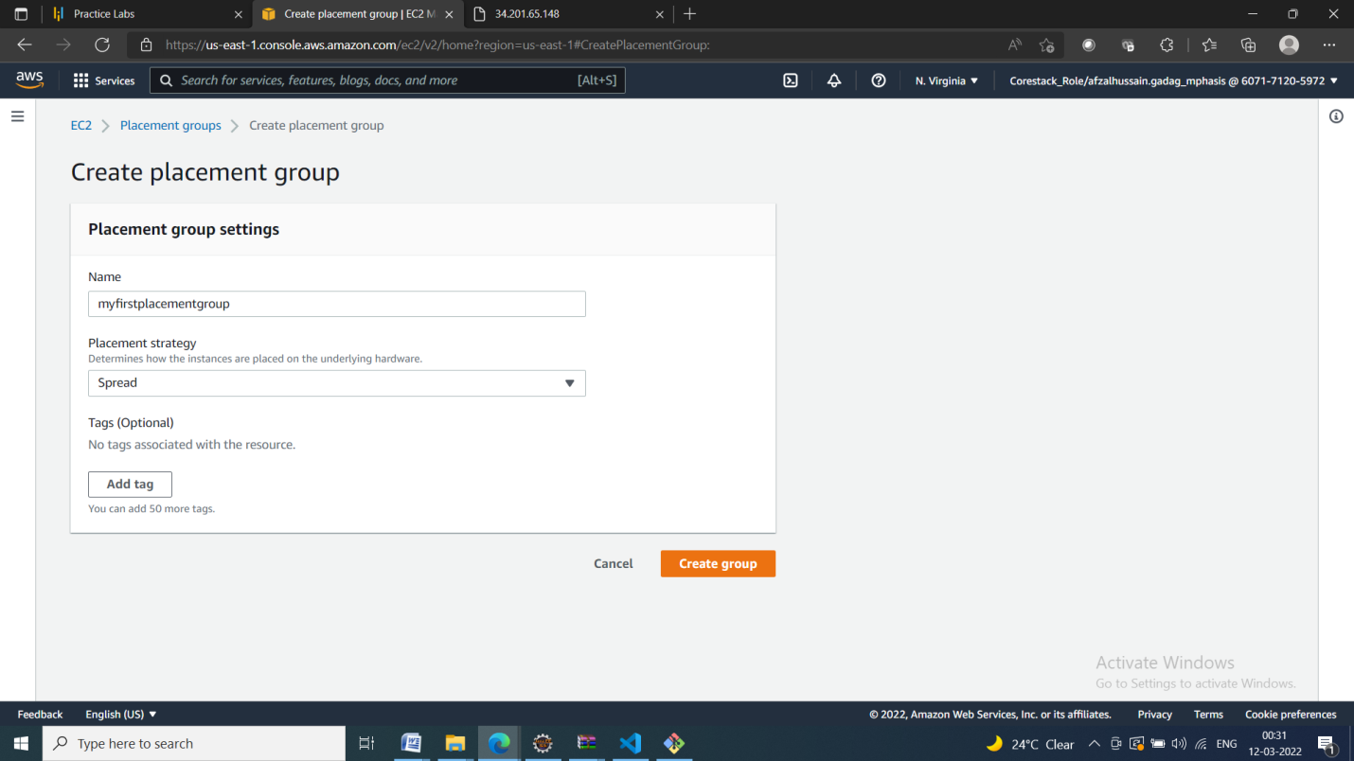

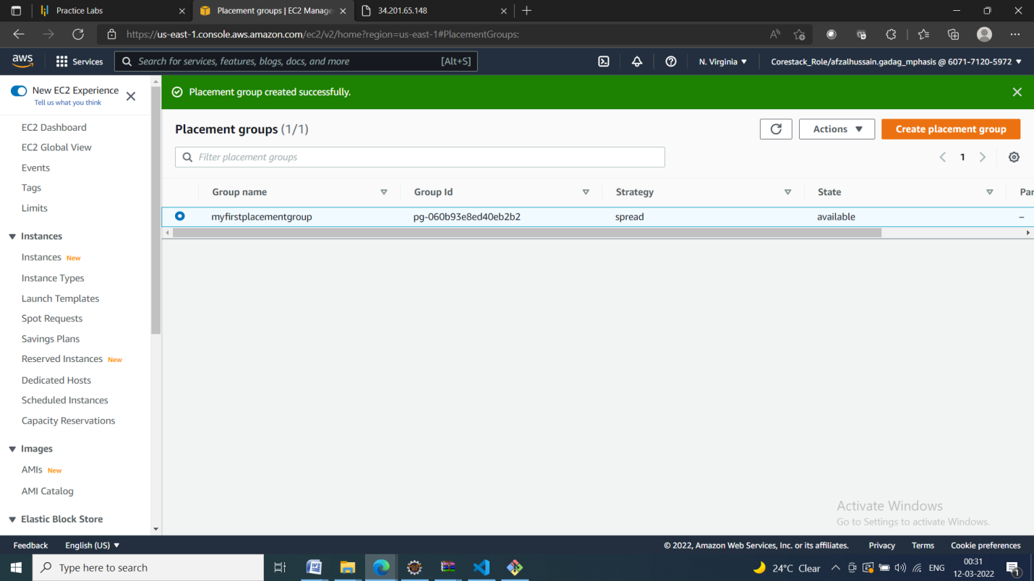

**Launching an Instance in the Placement Group:**

* Launch the new EC2 instance

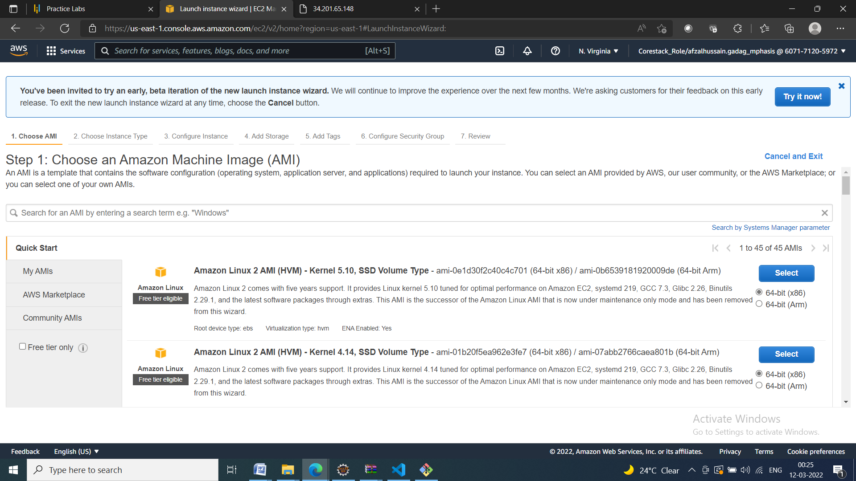

* Select the placement group

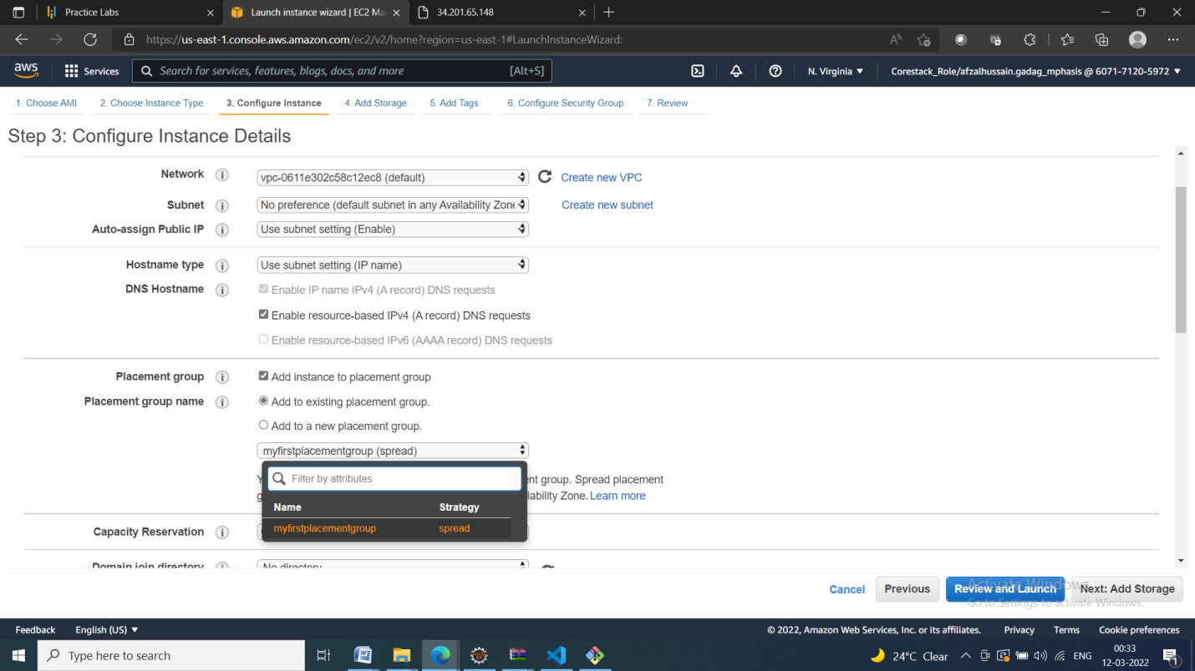

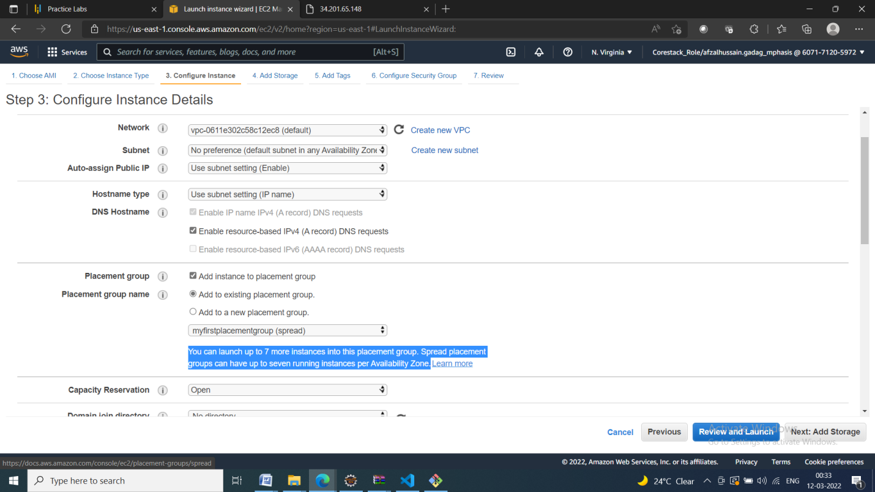

* Verify the placement group of the instance

